
Lesson 14 Teacher's Key: Raising the Stakes
TIC-80 - Instructor Reference Only
VIDEO GAME CREATION

What This Lesson Teaches
Same idea as every engine this week - replace hardcoded literals with wave-dependent formulas - expressed as plain Lua inside spawn_wave(), introduced in Lesson 11.

Level 1 - Full Worked Solution
- local count = 4 + wave computes the count once, then reuses it for both the spawn loop and enemies_remaining - a single source of truth by construction.
- No new fields are needed for Level 1 count scaling - only Level 2's speed scaling adds a new field (speed) to each enemy's table entry.
- Wave 1 still spawns exactly 5 (4 + 1 = 5), so nothing about the game's opening feel changes - only later waves escalate.
Highlighted lines are new this week; everything else is code you already have.
function spawn_wave()
enemies = {}
local count = 4 + wave
for i=1,count do
table.insert(enemies, {x=..., y=..., flash=nil})
end
enemies_remaining = count
end
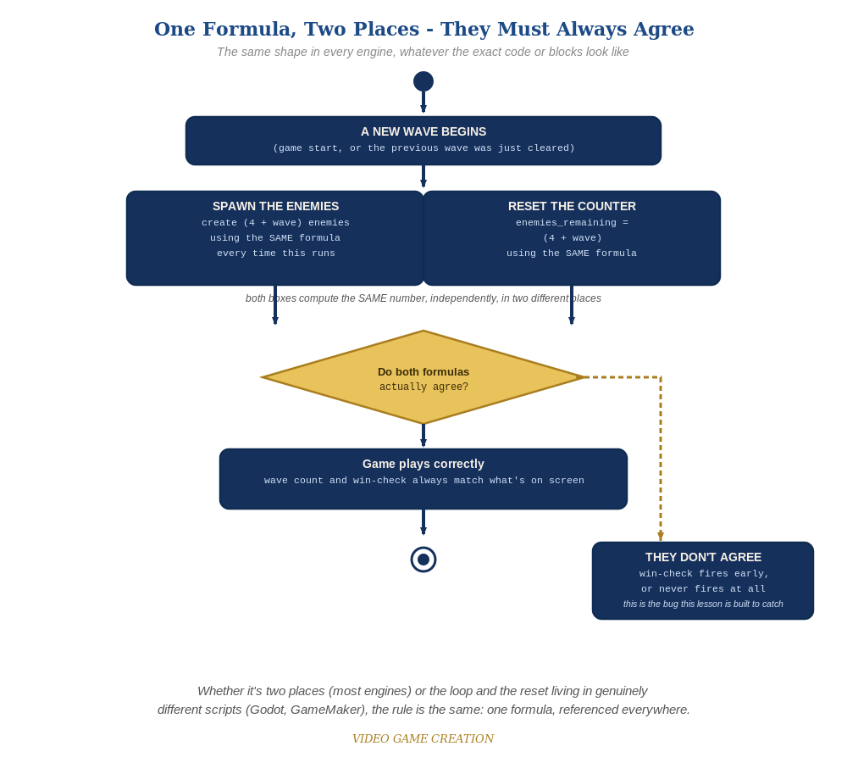
Whether the spawn loop and the reset live in two places or two genuinely different scripts, the rule is the same: one formula, referenced everywhere.

Why This Structure
- Storing count in a local variable (rather than repeating the formula) guarantees the spawn loop and enemies_remaining can never disagree - the same discipline as every other engine this week, in plain Lua.
- Adding a speed field to each enemy's own table entry (rather than a single global speed) keeps each enemy's full state - position, alive-ness, flash status from Lesson 13, and now speed - together in one place, the same discipline established since Lesson 4.

Level 2 / Level 3 Talking Points
- Ask students to trace spawn_wave() for wave 3 by hand: count = 4 + 3 = 7 - a good comprehension check.
- For students comparing engines: point out that GameMaker's identical (4 + wave) formula, expressed as GML instead of Lua, is conceptually the exact same idea - both engines needed a new per-instance/per-entry speed value where none existed before.
Level 2 - complete code:
Highlighted lines are the Level 2 additions on top of the Level 1 code above.
function spawn_wave() -- Level 2 addition, on top of the Level 1 code above
enemies = {}
local count = 4 + wave
for i=1,count do
table.insert(enemies, {x=..., y=..., flash=nil, speed=1 + (wave - 1) * 0.5})
end
enemies_remaining = count
end
-- movement code (revised to read e.speed instead of a leftover literal):
e.y = e.y + e.speed
Level 3 - no single combined code example:
This week's Level 3 is a "choose ONE" menu of five independent stretch features (destructible shields, a power-up, a bonus enemy, formation-marching movement, or a title/game-over screen) rather than the usual set of small, combinable stretch goals - so a single "all goals combined" code block doesn't fit Rule 14's usual model, and isn't provided here. Full worked solutions for all five options, across the active engines, are planned for the Lesson 15 wrap-up "Complete Codebase" send-home materials instead. Use the Talking Points above and the Handout's Level 3 menu to guide students toward whichever option they choose.

Common Student Mistakes
- Updating the spawn loop's count but forgetting to update enemies_remaining (or vice versa) - avoided entirely if count is stored in a local variable and reused.
- Setting speed on the table entry AFTER table.insert() instead of as part of the inserted table itself, which can silently fail depending on how the insert is written.
- Forgetting to change the movement code to read e.speed instead of a leftover literal - the field exists but is never actually used.

